21. Web Server (Apache)

Tasks

1.Install Apache web server on your Linux system and verify the installation by accessing the default Apache welcome page from your browser using localhost.

ANS:

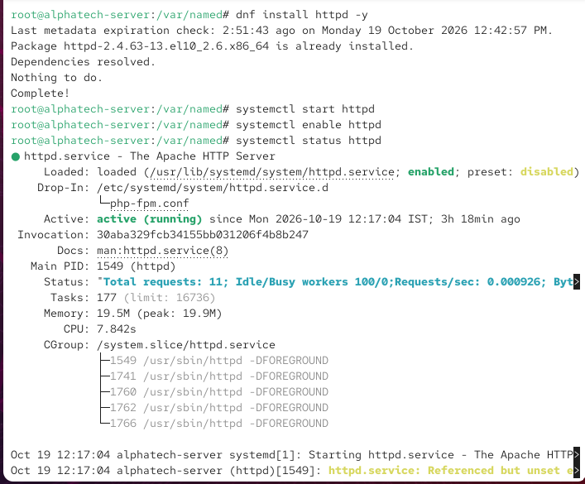

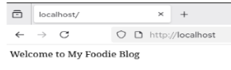

2. Change the default Apache web server homepage by editing the index.html file in /var/www/html to display your name and favorite IPL team.

ANS:

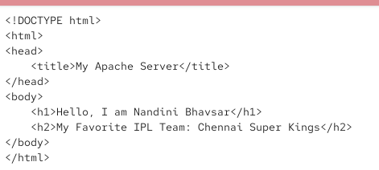

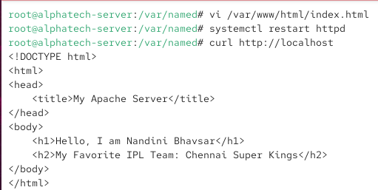

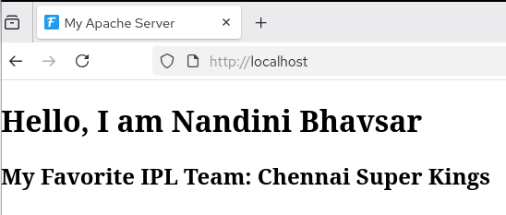

3.Configure a custom virtual host in Apache for a new domain called myzomatoclone.local that serves files from /var/www/myzomatoclone and test it by updating your /etc/hosts file.

ANS:

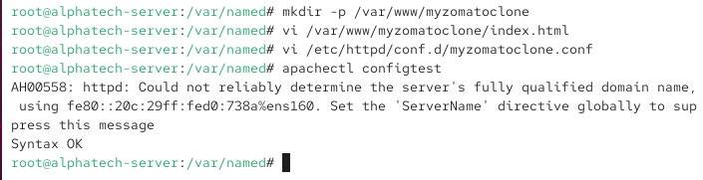

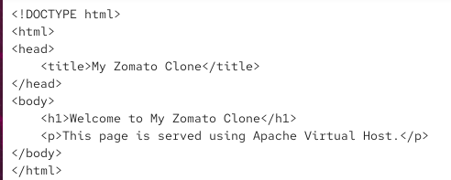

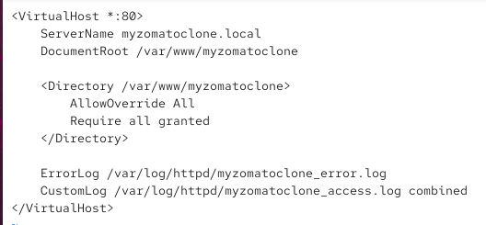

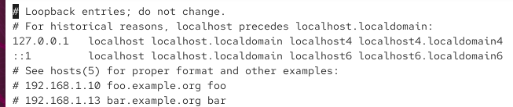

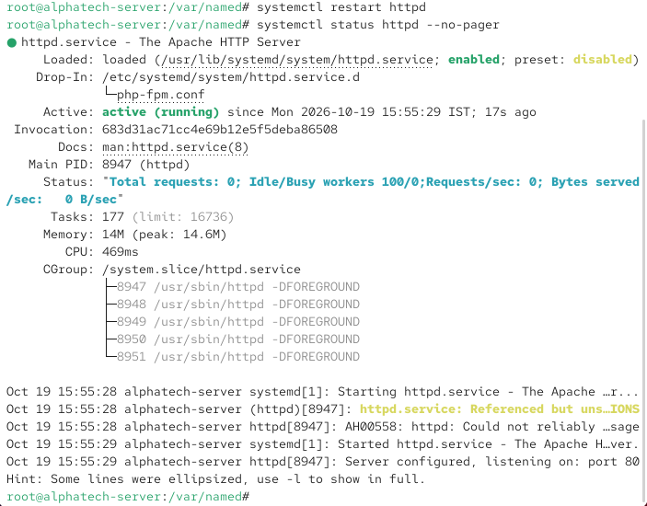

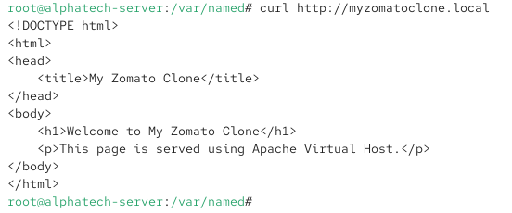

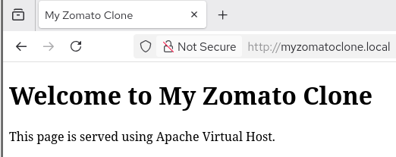

4. Enable and test the Apache mod_rewrite module by creating a rule that rewrites requests from /foodie to /index.html, then verify it works in your browser. Use the a2enmod command and edit the .htaccess file in your web root.

ANS:

